Table of contents
1. Purpose. 1
2. High level WBS. 1
3. High level schedule and network diagram. 5

Purpose.
Purpose of document is provide information about project schedule and estimation. Include Work breakdown structure – WBS, high level schedule and network diagram.

High level WBS.
Overview
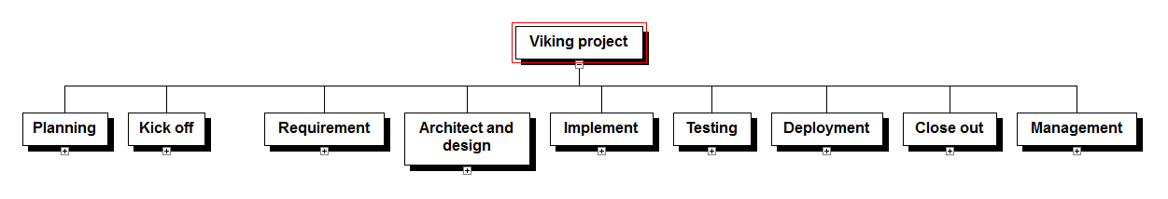
WBS of Viking project is described in process oriented. Include nine steps.
- Planning. Describe how do team prepare for new project. First, need to define goals and objects, estimate and make a master plan with high level schedule.
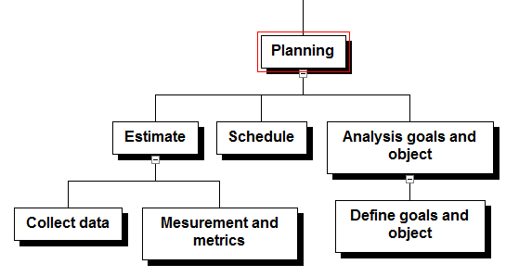
- Kick off. Describe how the project manager organize project teams, define changes and risk may be happened in project.
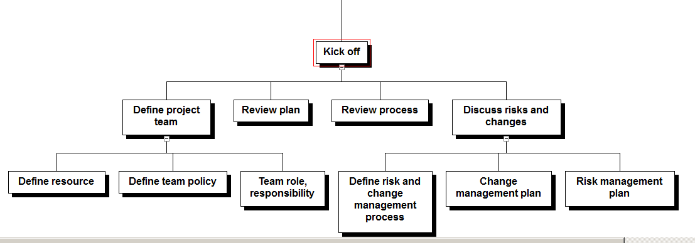
- Requirement.
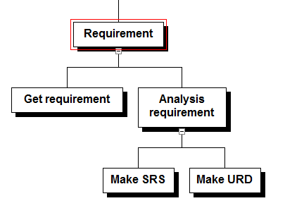
- Architect and design.
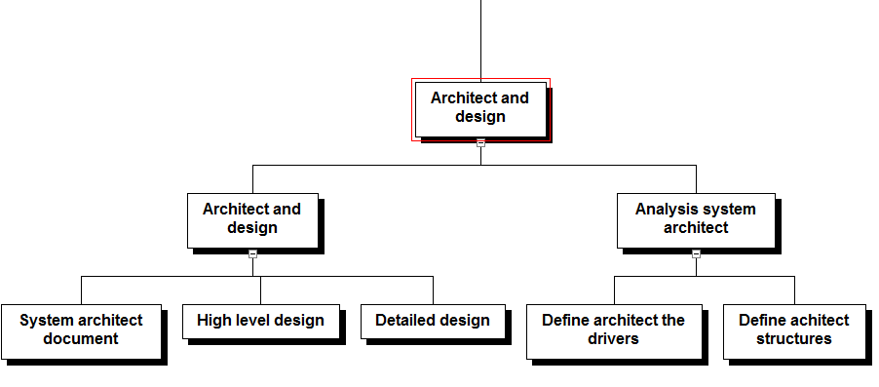
- Implement.
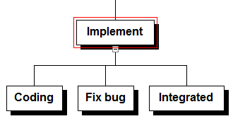
- Testing.
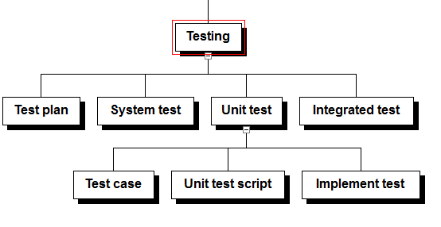
- Deployment.
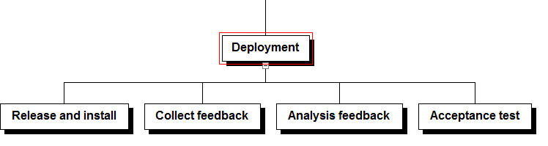
- Close out.
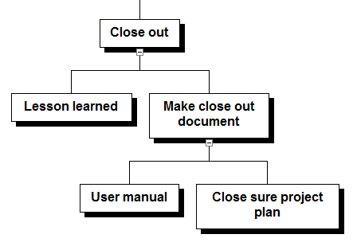
- Management. Describe how does manger control and monitol project.
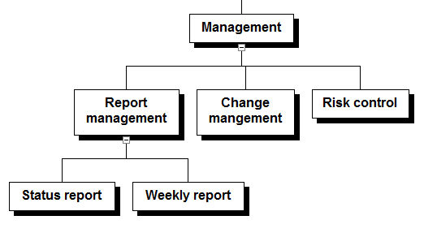

High level schedule and network diagram.

Read the attached document “K15T1-Team11-Team Assignment5.mpp”, Microsoft Project 2010.

